Git Hands-on Lab - 1
This repository was created as part of a Git Hands-on exercise.
It demonstrates basic Git commands, editor configuration, and pushing code to a remote GitLab repository.

1. Prerequisites
- Git for Windows (Git Bash)
- Notepad++
- GitLab account

2. Steps Performed
Step 1 — Verify Git Installation
git –version
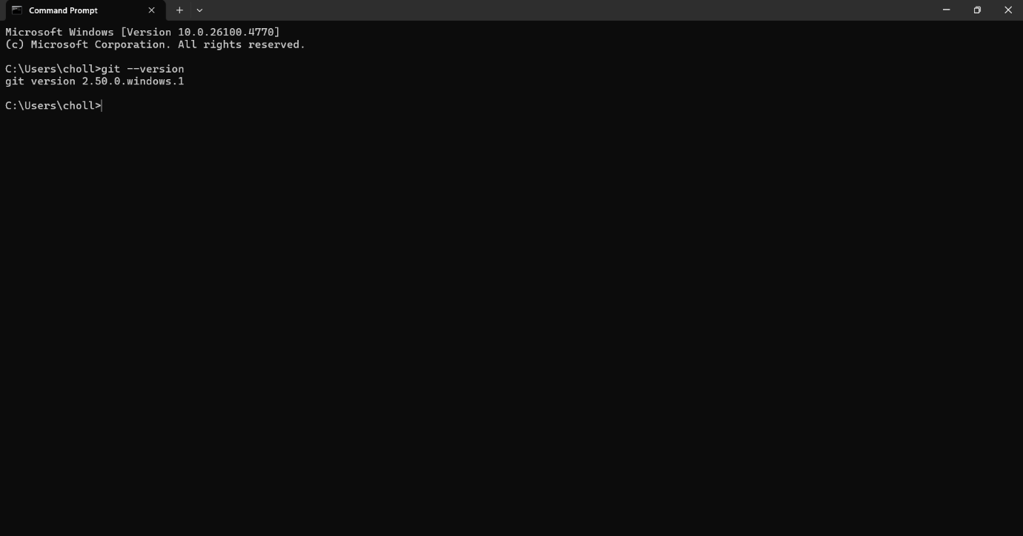

Step 2 — Configure Git Global Identity
git config --global user.name "Your Name"
git config --global user.email "you@example.com"

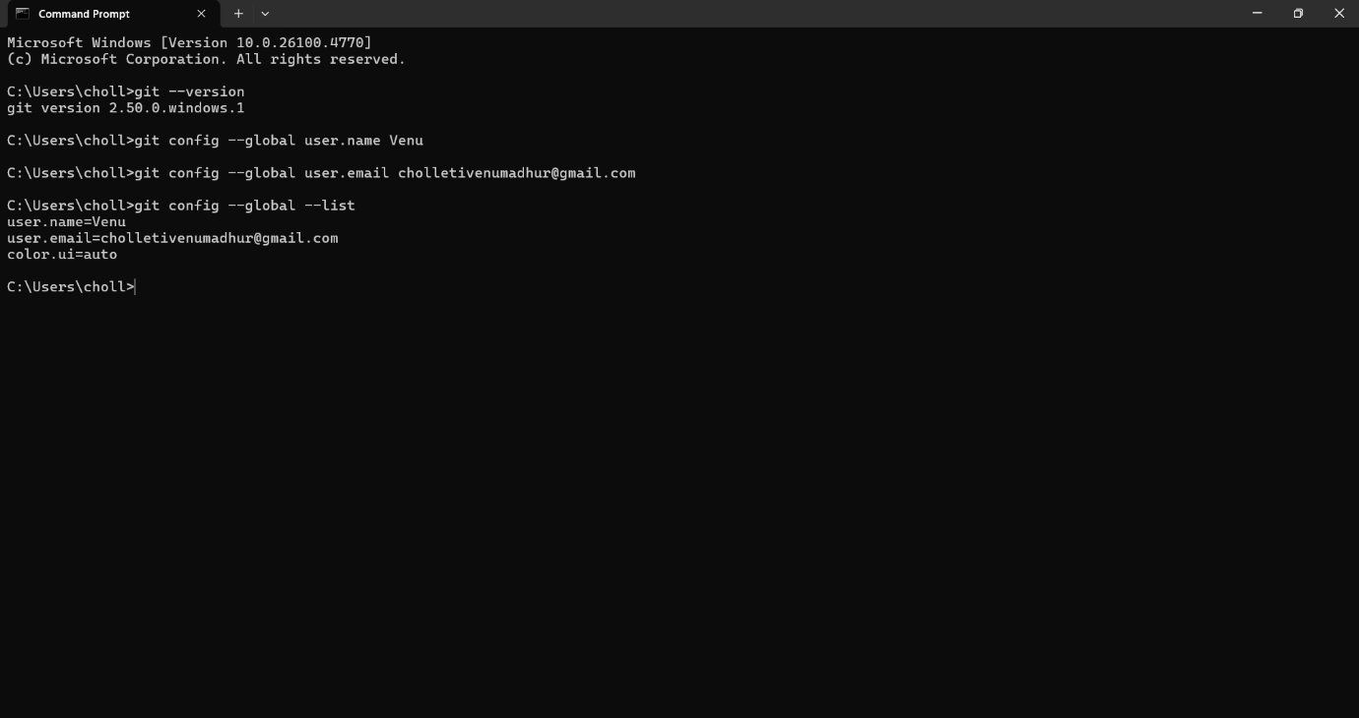

Step 3 — Set Notepad++ as Git Editor
Added C:\Program Files\Notepad++ to the system PATH, then:
git config --global core.editor "notepad++ -multiInst -nosession -wait"
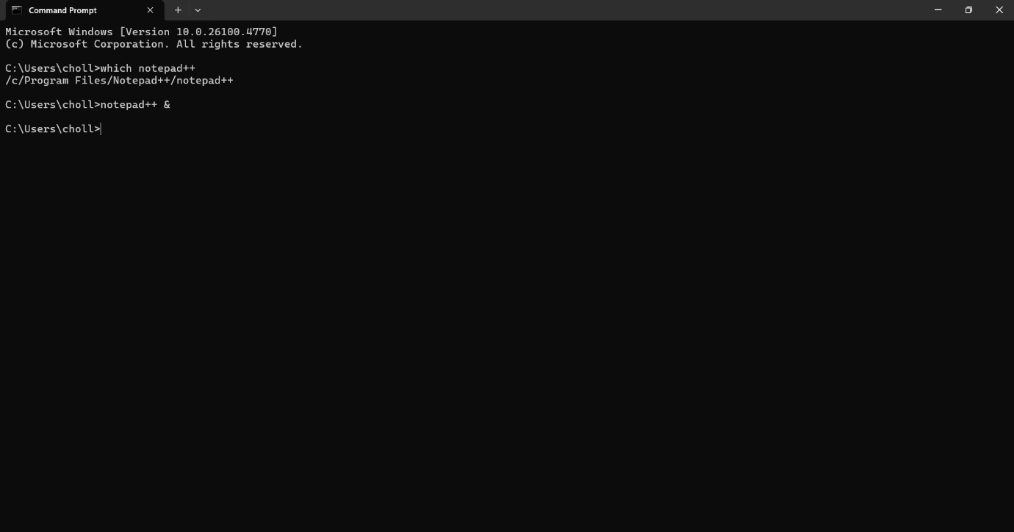

Step 4 — Create Local Repository
mkdir GitDemo
cd GitDemo
git init
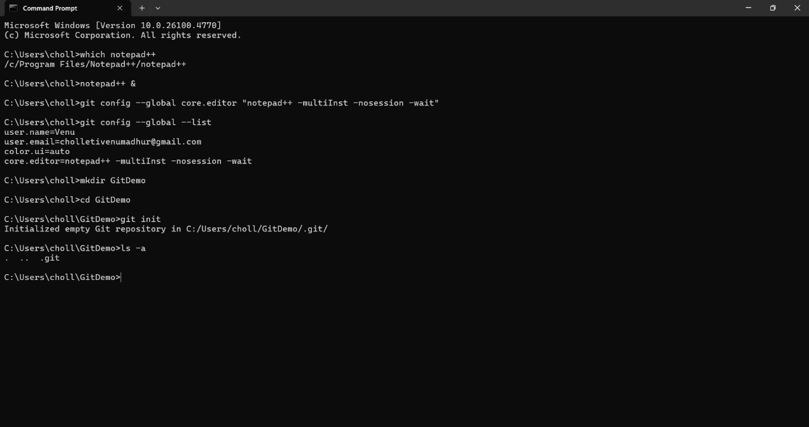

Step 5 — Create File and Check Status
echo "Welcome to GitDemo" > welcome.txt
git status
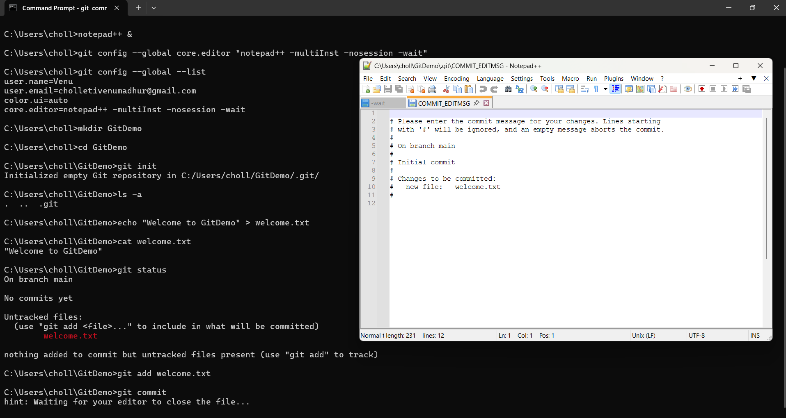

Step 6 — Stage and Commit File
git add welcome.txt
git commit
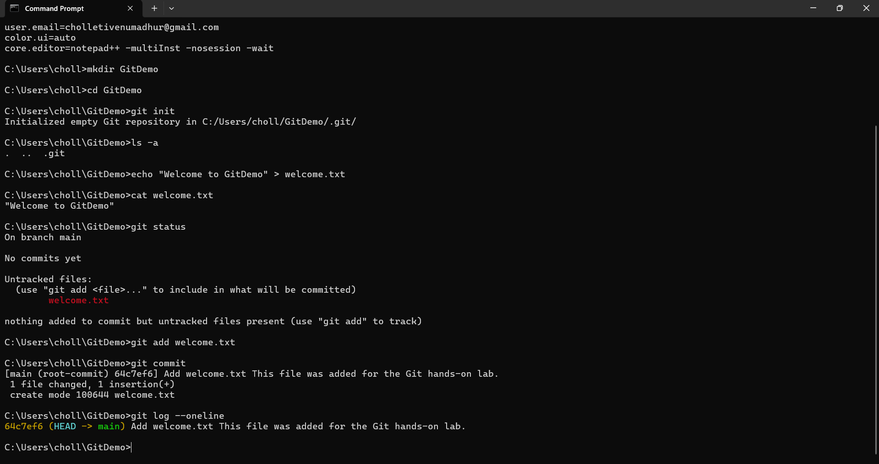

Commit message entered via Notepad++:
Add welcome.txt
This file was added for the Git hands-on lab.
Step 7 — Create Remote GitLab Repository
Created a project in GitLab named GitDemo.
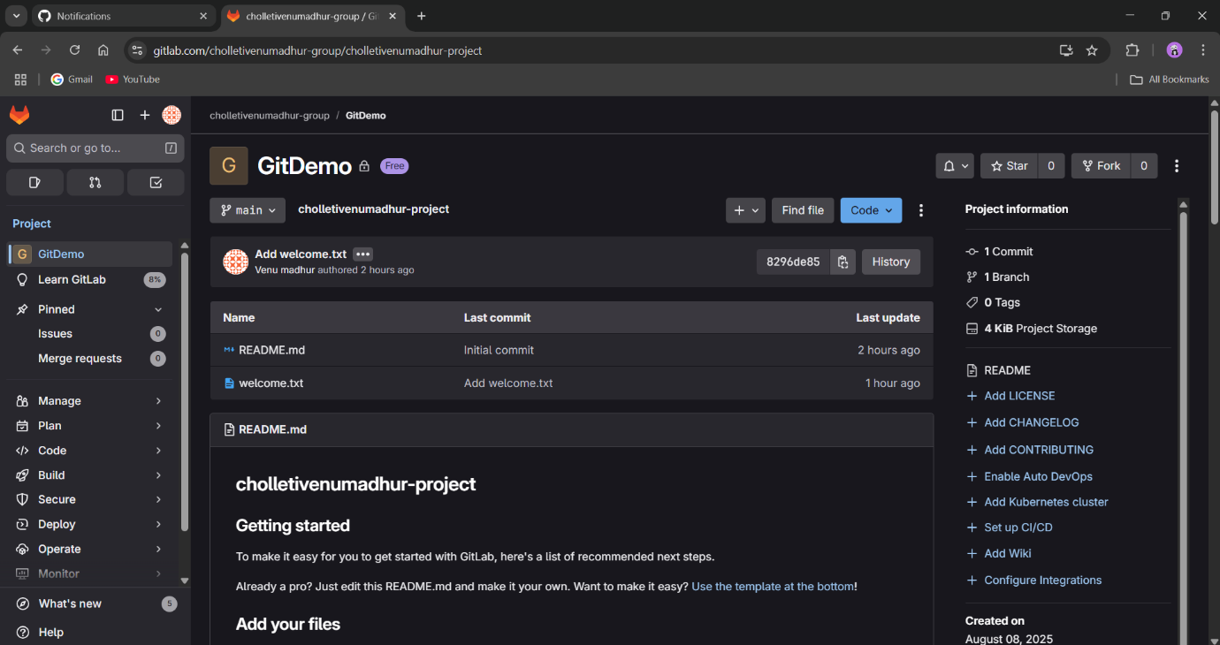

Step 8 — Link Remote and Push
git remote add origin https://gitlab.com/<group>/<project>.git

git pull --rebase origin main
git push -u origin main
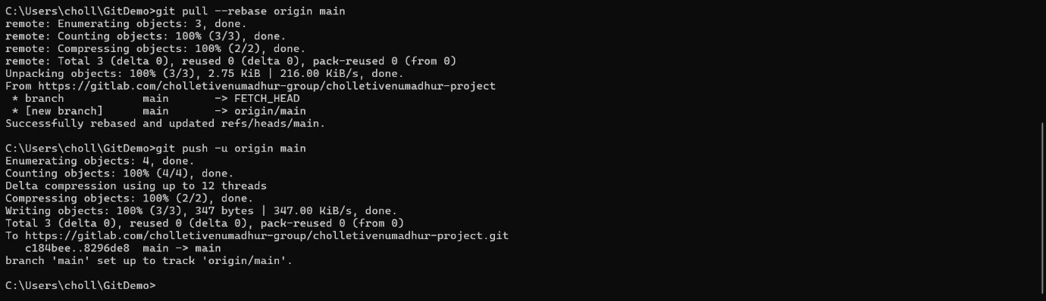

3. Verification
- Local repository initialized
- welcome.txt committed
- Repository linked and pushed to GitLab
- File and commit visible in GitLab web interface

